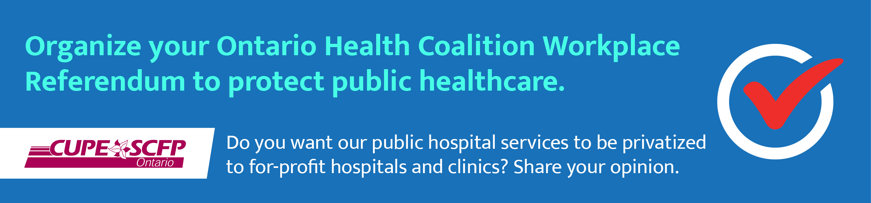

Sample letter of request to employer on why CUPE Local 1234 wants to conduct a workplace referendum
Proposed subject line: CUPE 1234 wants to hold a workplace referendum on public health care

Dear (contact name at EMPLOYER),

In conjunction with the Ontario Health Coalition (OHC) and CUPE Ontario, members of CUPE Local 1234 are speaking out on an issue that we believe is of vital interest and importance to the staff at EMPLOYER: the future of our public health care.

You are probably already familiar with the excellent work of the OHC, which is organizing province-wide community referendums on this very topic. CUPE 1234 supports the OHC’s initiative and, for that reason, we are seeking authorization from EMPLOYER to hold a workplace referendum for staff at EMPLOYER’s WORKSITE/ADDRESS.

These workplace votes will be held across Ontario from May 15 to 22; CUPE 1234 proposes that voting takes place between xx a.m. and xx p.m. Each ballot asks the same question of voters: “Do you want our public hospital services to be privatized to for-profit hospitals and clinics?” Votes will be secret and held in sealed ballot boxes until they are counted and the results relayed to the OHC.

Workplace referendums will be companions to the community referendums planned and organized throughout May by the Ontario Health Coalition; you probably saw some of the province-wide media coverage of its announcement on April 18.

In the lead up to a workplace referendum, CUPE 1234 requests permission to have volunteer members on site in the workplace, posting information, handing out leaflets and answering questions about the workplace referendum, including why it’s being held right here in our workplace.

We would like to set up voting stations with ballot boxes in the workplace. Volunteer members would enter each worksite so that they can ask everyone who works there to cast their ballot during the week of May 15-22, 2023. CUPE 1234 can assure EMPLOYER that our members will be courteous and respectful of the workplace environment at all times.

CUPE 1234 believes health care is an issue that everyone cares about. We hope that you agree and that we will have your approval for a workplace referendum.

Sincerely,

