July 19 Car Rally Participant Guide
Participants will assemble at 300 Victoria St. at 11:45am to decorate their cars (flags will be provided) before driving to the cavalcade route.
- Please follow the Cavalcade Route outlined in the map below — follow behind the audio-visual truck.
- Tune your car radio to 104.9 FM to listen to the event broadcast. Feel free to roll your windows down a crack and turn the volume up!
- The car rally will be held from 12 – 12:35pm, after which Local Leaders and CUPE Ontario spokespersons will make speeches. The event broadcast will continue on the radio channel, so participants have the option of listening to speeches from their vehicles.
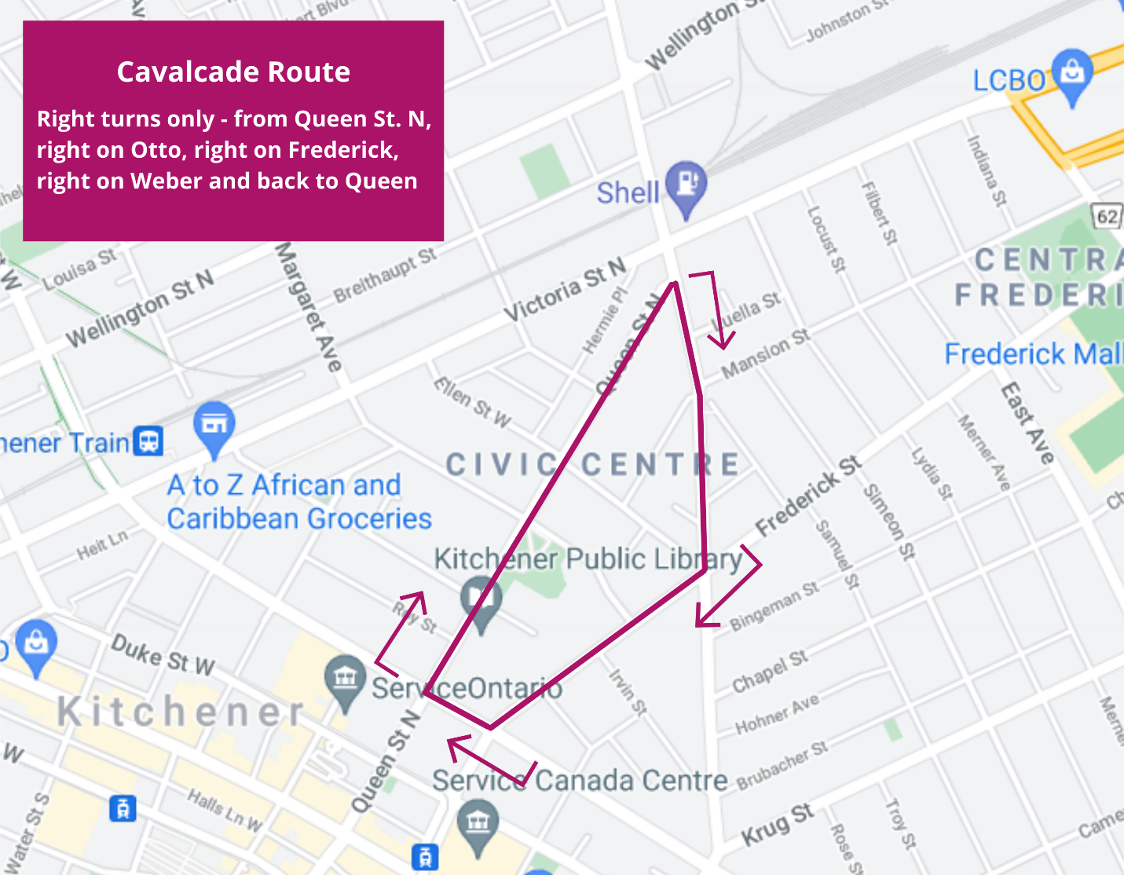
If you have questions, please contact Zaid Noorsumar (znoorsumar@cupe.ca).

