You’re all
Invited to
Lindsay & District Labour Council
Where We stand for Fairness
Annual 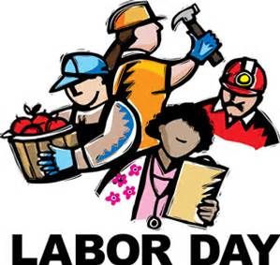
To celebrate workers contribution to their community
Sunday, September 4, 2016, beginning 12 pm
Old Mill Park, 16 Kent St. E. Lindsay
We challenge you to help us fill a Van with non-perishable food items
We will have a Bouncy Castle, games for the young participates, great music, dinosaur egg hunt (watermelons), and a barbeque.

