

Long-term Care Newsletter

UPDATES

It’s been a busy past few months for CUPE Ontario’s campaign to strengthen and improve our long-term care system. And a busy summer means a very busy fall – we’ll be ramping up our efforts to bring in 3.5 hours of dedicated, hands-on care for residents of long-term care facilities and reaching out to our members to get more informed and active in our campaign. This newsletter is part of this effort.

Will the Ombudsperson investigate the right things?

Ontario Ombudsperson André Marin announced on July 16 that his office would investigate how the province monitors long-term care facilities. CUPE Ontario President Sid Ryan welcomed his review, but urged him to look “at the right things”, namely the endemic lack of accountability that pervades the industry, particularly in the for-profit sector.

“Money is going in, but care levels are not rising accordingly. Mr. Marin needs to get to the bottom of why that’s happening, and why our call for minimum care standards is being rejected by the McGuinty government,” Ryan said. Marin must also ensure that workers are protected with “whistle-blower” legislation if they say anything that might make them vulnerable to reprisals from employers. CUPE will be watching to make sure that Marin’s probe isn’t used to justify cutting “onerous” regulations covering long-term care.

Ministry of Health and Long-Term Care’s regulatory review

CUPE participated in the MOHLTC’s review of the regulations covering Ontario’s long-term care sector this summer. The review was brief and inadequate, so we’ll be working with our partners in labour to make sure that any new regulations actually improve working conditions and quality of life for all residents of long-term care facilities.

“Sharkey” implementation committee

In July, the Liberal government created a table of long-term care “stakeholders” to implement the recommendations made by Shirlee Sharkey in her report on long-term care reform, but the government excluded half the unions that actually do the work. CUPE and its partners – the Ontario Nurses Association (ONA), the Service Employees International Union (SEIU) and the Ontario Public Service Employees Union (OPSEU) – lobbied the province to widen the table but the province shut the door on OPSEU and SEIU. Only CUPE and ONA are “at the table”, but we’re working closely with all our partners to make sure all of labour’s concerns are heard. Candace Rennick, CUPE Ontario 2nd Vice-President, is CUPE’s representative. She is tasked with bringing CUPE’s campaign for minimum standards of care to the table.

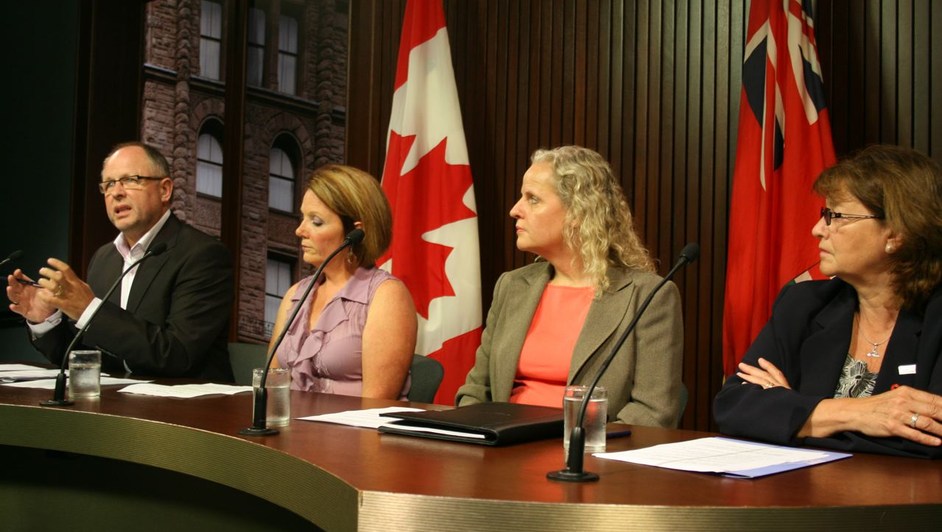

Pushing for minimum care standards in long-term care Sid Ryan is joined for a Queen's Park media conference with Sharleen Stewart, President of the Service Employees International Union (SEIU) Local 1 Canada, Vicki McKenna, RN, First Vice-President of Ontario Nurses Association (ONA), and Patty Rout, First Vice-President of the Ontario Public Service Employees Union (OPSEU).

Sharkey’s report explicitly rejected CUPE’s policy recommendation of a 3.5-hour minimum care standard, so Rennick says the union will continue to press for “3.5” at the table – and in our communities. “Having a voice on this committee is another opportunity for CUPE and for labour to push the McGuinty government to implement a minimum care standard of 3.5 hours of hands-on care per resident per day,” Rennick says. The group has held one phone meeting and is planning 3 face-to-face meetings in September to discuss the development of a staffing plan template. Updates will follow.

Funding Announcement

The recent provincial budget committed dollars to increase the amount of PSW, RPN and RN hours into long-term care facilities. On August 20th the Liberals announced the first phase of this funding for PSWs only – an initial investment of $23 million to hire 873 fulltime-equivalent PSWs. Funding will flow into the Nursing & Personal Care envelope directly from the Local Health Integration Network (LHIN). Each home will be required to sign an accountability agreement with the LHIN confirming the funding will be used to produce “net new” PSW hours. To find out how much funding your home received visit www.cupe.on.ca and click on Campaigns – LTC.

Mass rally for public health care

CUPE Ontario is moving forward on a resolution passed at May’s convention to mobilize CUPE members to a MASS rally to protecting public health care. The Ontario Health Coalition (OHC) has organized rallies in 5 communities for September 27, including Toronto (Queens Park), Kingston, Windsor, Sudbury and Thunder Bay. The theme for the mass protest is “Listen up McGuinty! Support Public Health Care: Regulate a Minimum Care Standard in Long Term Care, Stop P3s, Stop the Cuts to Hospital Services; Stop competitive bidding in Home Care for good, Stop Privatization and two-tiered extra billing!!”

DON’T MISS OUT! Bring you’re family, friends, pets! Ontario’s long-term care workers need to turn out in large numbers to these protests and make their voices heard! The government will be watching – and, hopefully, listening! CUPE Ontario will pay for buses or transportation costs to one of the 5 protests. To organize a bus, van or car from your area, visit www.cupe.on.ca for info or contact Candace Rennick at 705-743-0600 ext 26 or crennick@cupe.ca



Going forward

CUPE Ontario is ramping up its campaign for a minimum care standard of 3.5 hours. We are launching a major effort to communicate to our members and encourage them to take action to improve working conditions throughout sector. With your help, we’ll make things better.

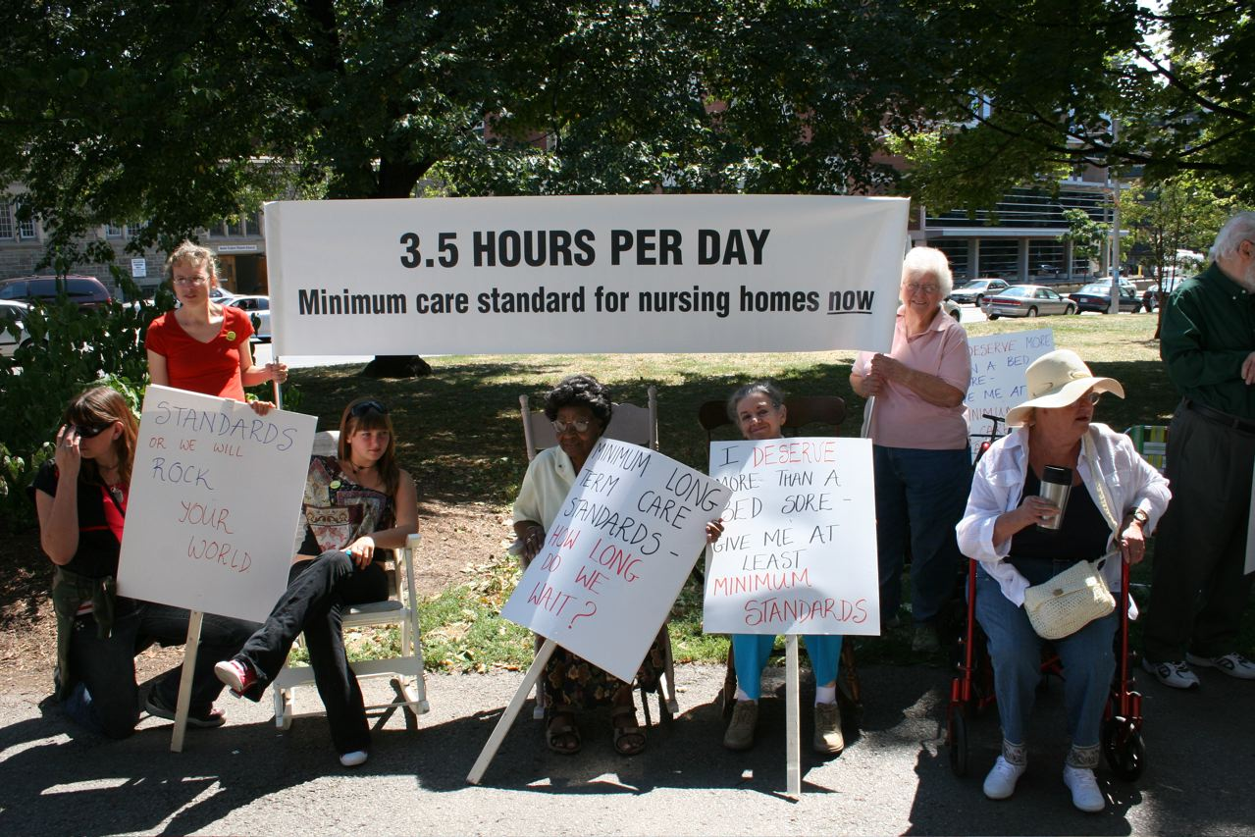

CUPE Q&A
What is CUPE Ontario doing to improve long-term care?

- Campaigning for “3.5” hours of care per resident per day;
- Bringing your voice to the “Sharkey” committee;
- Working with the Ombudsperson to make sure he looks at “the right things”;
- Press conference at Queen’s Park on Ombudsperson’s investigation;
- Lobbying the province for stronger regulations;
- Protecting workers by calling for “whistle-blower” legislation;
- Advocating protocols for workers if they meet with the Ombudsperson and Ministry officials from the regulatory review group;
- Mobilizing members to participate in the September 27 day of action to achieve a minimum care standard;
- Rolling out press conferences across the province on recent funding announcements for PSWs, promoting our research for areas 2,3,5,6 and 7.

Why is CUPE campaigning
for 3.5 hours?

CUPE members and other long-term care workers provide the best level of care they can in a system that is chronically underfunded and short-staffed. Our long-term care system keeps workers rushing from resident to resident without being able to connect with and support them adequately. Our system is failing its seniors and not providing them with the care they deserve and need. Funding increases have not translated into more care, especially in the for-profit sector. This must change. We need the accountability of minimum standards, and 3.5 hours of hands-on care is the amount of care that our workers – and several research studies – have identified as adequate, necessary, and fair.
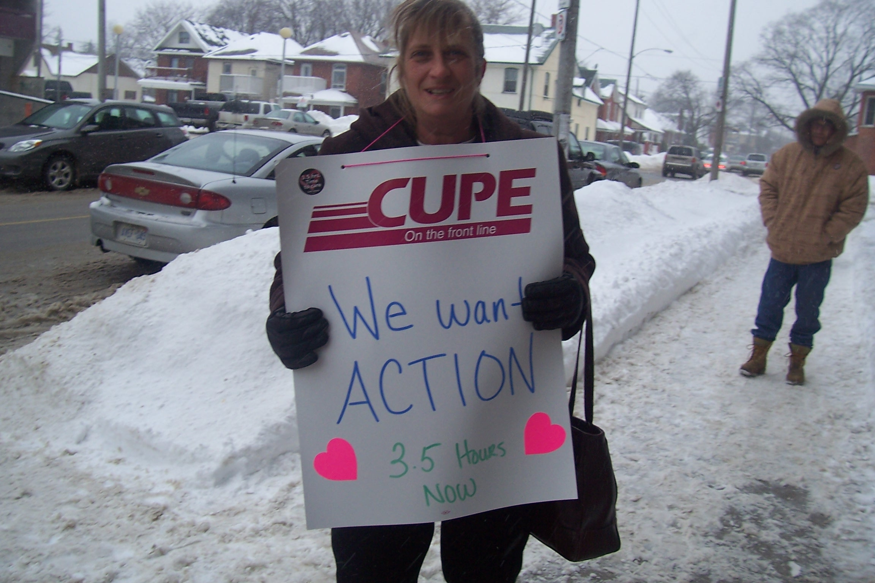
Verna Pink – Local 2280

Doesn’t the government say they are funding 3.25 hours already?

The government calculates the number of care-hours in a way that over-inflates the figures. The province says that the number of actual care-hours can be measured by how much money flows into a facility, but CUPE and other unions argue that the more accurate way to measure hours of care is to add up the number of hours worked by hands-on staff. The province is also adding in the hours of other allied health professionals, such as nurses and social workers, whose work may or may not amount to actual “hands-on” care. The studies that CUPE and its partner unions have conducted show that hours of care are hovering around 1.9 to 2.7 hours per resident per day despite millions of dollars in new funding, because the money is flowing without the government keeping facilities accountable.

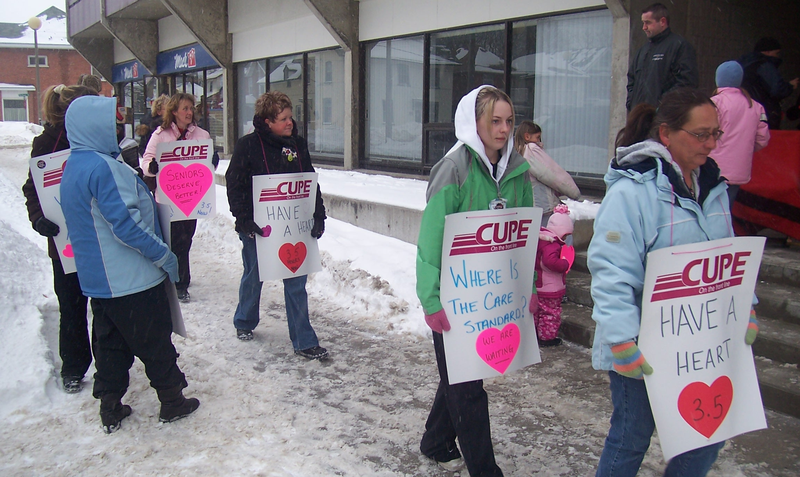
Members of Local 2280

What do we think of the Ombudsperson’s investigation?

CUPE Ontario welcomes the Ombudsperson’s investigation but cautions that he must look at the right things, especially at accountability and making sure that increased funding translates into increased care. CUPE Ontario is also calling for “whistleblower” protection for any workers who speak up during the Ombudsperson’s review.

What does the Sharkey report mean?

The McGuinty government has promised repeatedly – and failed – to bring in minimum standards of care. Instead, it commissioned a report by Shirlee Sharkey, a former hospital administrator and private home care industry lobbyist, to make recommendations on how to improve Ontario’s long-term care system. Problem is, Sharkey’s report explicitly rejected minimum care standards, which means our campaign must heat up.

Why are we on the Sharkey implementation committee?

We are at the table as one of two labour representatives to provide workers’ perspectives on all recommendations in Shirlee Sharkey’s report. We will continue to press for 3.5 hours of care and to educate other members of the committee about the reality of our long-term care system.

COPE 491/gpb

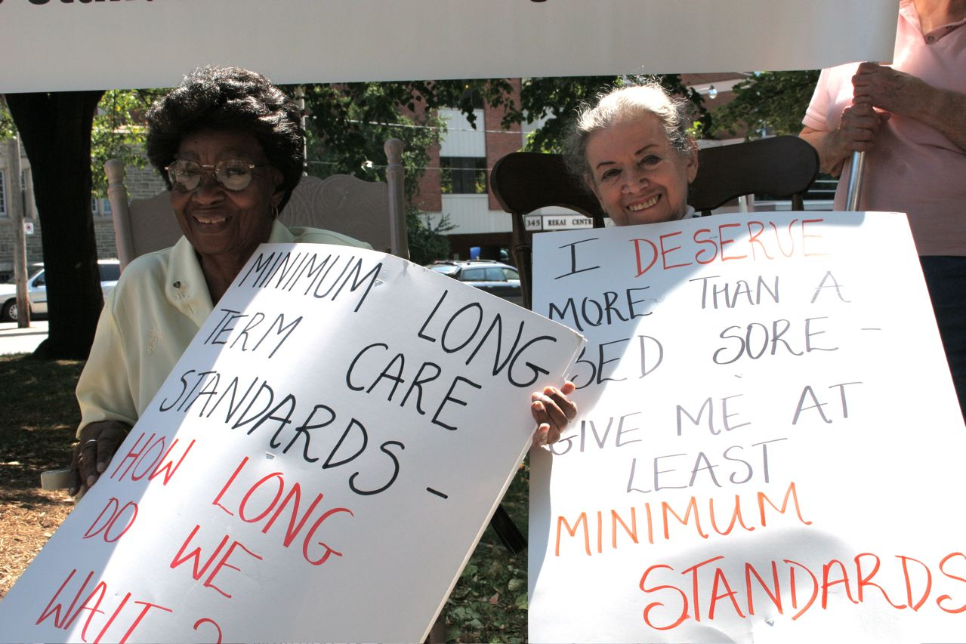

What should I do if I’m approached by the Ombudsperson’s office for an interview for his investigation?

If you’re approached by the Ombudsperson’s office, tell your local president and contact us at the Ontario Division office at 416-299-9739. We’ll help you prepare and support you through the process.

